Math 601 Rational Functions DRAFT Name:

A "rational expression" is a polynomial fraction, and anything you could do with rational numbers you can do with rational expressions. However, since there are variables in rational expressions, there are some additional considerations.

Finding the domain of a rational expression:

When you dealt with rational numbers, you encountered simple fractions. These rational numbers could have any whole numbers for the numerator and any number except for zero as the denominator. When evaluating a rational expression, you will often need to evaluate the expression, and it can be useful to know which values would cause division by zero, so you can avoid these x-values. Therefore the first thing you will do with rational expressions is find their domain.
Find the domain of :
The domain is the set of all possible values for x. Since the denominator may not equal zero (division by zero isn't allowed), you need to find all values of x that make the denominator equal zero. The domain will then be all other x-values. When is this denominator equal to zero? When x = 0.
Therefore domain = {x: x ≠ 0}

Determine the domain of :
The domain isn’t determined by what is in the numerator of a rational expression. The domain is only influenced by the zeroes of the denominator. Will "3" ever equal zero? No, the constant 3 in the denominator will never equal zero, no matter what value x takes on, therefore there are no forbidden values for this rational expression, and x can be anything.
Therefore domain = {x: x ∈ R}

Determine the domain of 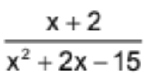:
Remember that you can ignore the "x + 2" in the numerator (since the numerator does not cause division by zero), instead you will set the denominator equal to zero, and solve. The x-values in the solution will be the x-values that would cause division by zero. The domain will then be all other x-values.
x² + 2x – 15 = 0
(x + 5)(x – 3) = 0
x = –5, x = 3
Therefore domain = {x: x-5, 3}

As evident above, you will need strong factoring skills to find the domain of many rational expressions.

Factoring:

A "quadratic" is a polynomial that looks like "ax² + bx + c", where "a", "b", and "c" are just numbers. Not every quadratic is factorable. In the next sections you will learn skills for factoring various types of quadratics, as well as how to determine if a quadratic is prime (not factorable). Presently we will limit ourselves to rational factors.

For the easy case of factoring, when the “a” term equals 1, you factor by finding two numbers that will multiply to equal "c", the constant term, but also add up to equal "b", the coefficient on the x-term (the linear term). For instance:

Factor x² + 5x + 6:
Find factors of 6 that add up to 5. Since 6 can be written as the product of 2 and 3, and since 2 + 3 = 5, use 2 and 3.
Thus the factors of x² + 5x + 6 are (x + 2) and (x + 3).

Note that you can always check your work by multiplying back to get the original answer.

This is the easiest type of factoring.

Please factor each of the following:
1. x² + 7x + 6 2. x² – 13x + 6 3. x² – 7x + 6
4. x² + x – 6 5. x² – x – 6

Another simple type of factoring is factoring out a common monomial term.

Factor x²y³ + xy:
You can factor an "x" and a "y" out of each term.
Therefore x²y³ + xy = xy(xy² + 1).

In general, you look to factor out this any common monomial term as a first step any time you factor. After this is completed, you will factor any polynomial that is left.

Please factor each of the following:
6. 3x³ + 6x² – 15x 7. 5x³ – 5x² – 100x 8. 9x² + 18x – 27

Factor 2(x – y) – b(x – y):
This may look different from above, but really it's not. The two terms, 2(x – y) and – b(x – y), do indeed have a common factor; namely, the parenthetical factor x – y. You factor out this common binomial factor just as if it were a monomial- this is the converse of the distributive property.
Therefore 2(x – y) – b(x – y) = (x – y)(2 – b).

This will be a useful skill as we continue with factoring.

Another easy type of factoring is factoring by grouping. There are two types of factoring by grouping. One of these is to think of is as factoring in pairs. The other type involves perfect square trinomials. This will be covered later in the packet.

To factor "in pairs", you split the expression into two pairs of terms, and then factor the pairs separately.

Factor xy – 5y – 2x + 10:
First group xy – 5y and –2x + 10.
Through the converse of the distributive property, xy – 5y = y(x – 5) and -2x + 10 = -2(x – 5)
Therefore, xy – 5y – 2x + 10 = y(x – 5) – 2(x – 5)
Now factor out common term(s):
Therefore xy – 5y – 2x + 10 = (x – 5)(y – 2)

Please factor each of the following:
9. x² + 4x – x – 4 10. x² – 4x + 6x – 24 11. 2x2y – 42y2 2– 232x2 2+2 2122
12. x³ + 3x² + 9x + 27 13. 2x² + 6x³ + 5x⁷ + 15x⁸

It is a bit trickier to factor quadratics when the lead coefficient (the number on the x² or quadratic term) is not 1, since we have to be sure that our factors will produce all three coefficients, rather than just two in the easier cases above. This can be done either by guess and check or by splitting the middle term.

Factor 6x² + x – 2 by guess and check:
First you need to find all of the factors of the “a” term. If this is a positive number you can restrict yourself to positive factors.
Factors of a: 1,6 and 2,3
Then you need to find the factors of the “c” term.
Factors of c: 1,-2 and -1,2.
You now need to figure out which combination gives the appropriate “b” term. You try different combinations until you find the correct one. You can test combinations by completing the “Inside” and “Outside” of FOIL (a method for multiplying binomials: First, Outer, Inner Last).
(x + 1)(6x – 2)
Inside: 6x
Outside: -2x
Sum: 4x
This does not work since 4x does not equal the needed middle term of x. Therefore you keep repeating your trials until you guess correctly.
(x – 1)(6x + 2)
-6x + 2x = -4x.
This does not work.
(2x +1)(3x – 2)
3x – 4x = -x
This does not work.
(2x – 2)(3x + 1)
-6x + 2x = -4
This does not work.
(2x –1)(3x + 2)
-3x + 4x = x
Therefore 6x² + x – 2 = (2x – 1)(3x + 2)

Factor 6x² + x – 2 by splitting the middle term.
First you multiply "a" and "c" terms.
6(-2) = -12
Then you find factors of the product "ac" that add up to "b".
4(-3) = -12 and 4 + (-3) = 1
Next, rewrite the original polynomial splitting the middle term into the two factor from part B.
6x² + 4x – 3x – 2 or 6x² – 3x + 4x – 2
Finally, factor the resulting polynomial by grouping.
2x(3x +2) – 1(3x + 2) or 3x(2x – 1) + 2(2x – 1)
(3x + 2)(2x-1) or (2x – 1)(3x + 2)
Therefore 6x² + x – 2 = (3x + 2)(2x-1)

Some students prefer a slightly more visual variation on this sometimes called the “diamond and box” method, which your teacher may choose to show you in class.

Please factor each of the following:
14. 4x² – 19x + 12 15. 5x² – 10x + 6 16. 2x² – 4x – 16
17. –6x² – x + 2 18. –6x² + 15x + 36 19. 6 + x – x²

Sometimes when splitting the middle term, the product you get when multiplying the a and c terms is very large. You therefore must think logically to narrow down the possibilities.

Factor 20x² – 17x – 63:
Multiplying a and c, you get (20)(–63) = –1260. Finding the factors is not as obvious as it was in the prior questions. You do know that those factors will have opposite signs (since only factors with opposite signs will produce a negative product), and that they'll be seventeen units apart (since the b is -17). Therefore make a list of factor pairs, and see which fit these qualifications.
factor pairs
Now that I have my list of factor pairs, I can subtract the pairs to find the differences. If there is a pair of factors with a difference of 17, then I can factor the quadratic. If not, then I will know that the quadratic is prime.

Note: a prime number cannot be factored, just as a prime polynomial cannot be factored.

Since 45 – 28 = 17
20x² – 28x + 45x – 63
4x(5x – 7) + 9(5x – 7)
Therefore 20x² – 17x – 63 = (5x – 7)(4x + 9)

1, 1260
2, 630
3, 420
4, 315
5, 252
6, 210
7, 180
9, 140
10, 126
12, 105
14, 90
15, 84
18, 70
20, 63
21, 60
28, 45
30, 42
35, 36

Please factor:
20. 56x² + 107x + 45

Sometimes factoring problems look more difficult than they truly are.

Please factor each of the following:
21. 6x² + xy – 12y² 22. x⁴ – 2x² – 8 23. x⁶ + 6x³ + 5
24. x^{2/3} – x^{1/3} – 6 25. x + 5x^{1/2} + 4 26. (x – 3)⁴ + 2(x – 3)² – 8

There are also some special cases when factoring. These are perfect square trinomials, the difference of two squares, and both the sum and difference of two cubes. These all have special formulas associated with them.

You have seen perfect square trinomials in the quadratic function unit that was covered earlier in the year. These polynomials occur when you square a binomial.

(x + 4)²
(x + 4)(x + 4)
x² + 4x + 4x + 16
x² + 8x + 16

The key to recognizing when a polynomial is a perfect square trinomial can be found in the step
x² + 4x + 4x + 16. Both the “a” and “c” terms are perfect squares (remember that any variable to an even exponent is a perfect square, i.e.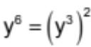, meanwhile there are two middle terms that are exactly the same. Therefore it could be thought of as x² + 2(4x) + 16. This is true about all perfect square trinomials. The rule is therefore

a² + 2ac + c² = (a + c)² or a² – 2ac + c² = (a – c)²

Please factor each of the following:
27. x² – 10x + 25 28. x² – 8x + 9 29. 9x² + 24x + 16
30. 36x² - 204 + 289 31. 50x³ + 180x² + 162x

The key to recognizing the difference of two cubes can be found in reexamining conjugates. When you multiplied complex conjugates, the middle term disappeared and you were left with a real number. In fact, any time you multiply conjugates the middle term will disappear. Therefore (4x + 9)(4x – 9) becomes 16x² – 36x + 36x – 81 when FOILed. When like terms are combined the answer becomes 16x² – 81. Thus it is called the difference of two squares based on the fact that you are subtracting two square terms. The rule is therefore:

a² – c² = (a + c)(a – c)

Please factor each of the following:
32. 36x² – 289 33. 225x² – 1 34. x⁴ – 64
35. 9x⁶ – y⁸ 36. x⁴ – 16 37. (x + y)² – (x – y)²

The other two special factoring formulas are the sum and difference of cubes. These are the formulas:

a³ + b³ = (a + b)(a² – ab + b²) or a³ – b³ = (a – b)(a² + ab + b²)

Next year you'll learn how these formulas were derived. For now, just memorize them. First, notice that, ignoring the signs, the terms in each factorization are the same; then notice that each formula has only one "minus" sign. For the difference of cubes, the "minus" sign goes with the linear factor, a – b; for the sum of cubes, the "minus" sign goes in the quadratic factor, a² – ab + b².

Note: The quadratic part of each cube formula is prime, so don't attempt to factor it.

Please factor each of the following:
38. x³ – 8 39. 27x³ + 1 40. x³y⁶ – 125
41. x⁶ – 64 42. 27x³ – 8 43. 7x⁷ – 56x
44. (x + y)³ + (x – y)³

Now that the special cases have been discussed, the other form of factoring by grouping can be discussed. In this case, instead of grouping into pairs, you separate a monomial term from a grouped perfect square trinomial. You then factor the perfect square trinomial into a binomial squared. This leaves a polynomial that can be factored as he difference of two squares.

Factor x² – 10x + 25 – y²:
(x² – 10x + 25) – y²
(x – 5)² – y² Note: This is the difference of two squares, only the first square is a
(x – 5 + y)(x – 5 – y) binomial.

Please factor each of the following:
45. x² + 6x + 9 – y² 46. a² – b² + 2b – 1 47. p² – 4y² +4y – 1
48. 81 – x² + 2xy – y²

You will save a lot of time spent attempting to factor quadratic binomials and trinomials if you can first discover if they are prime (and thus not factorable). The easiest way to do this is to use the discriminant (b² – 4ac). If the discriminant is a perfect square it is factorable, otherwise it is prime.

Please factor each of the following or say it is prime:
49. 18x² + 27x + 10 50. 6x² – 27x + 20 51. a²b⁴ – a⁴b²
52. 7a²x – 6a² – 7x + 6 53. 2x² + xy – 3y² 54. 7x⁴ – 28x²
55. x⁴ – 26x² + 25 56. 7x³ – 14x² – 3x + 6 57. 81x² + 108x + 36
58. 35x² – 2x – 6 59. 343 – 7(x + 3)² 60. x¹² – y¹²
61. 16x² + 56xy + 49y² 62. 8x⁴ + 44x³ + 56x² 63. 6x³y² + 54x²y² – 312xy²

Calculate the discriminant and use it to tell whether or not the trinomial is prime.
64. 3x² – 15x + 14 65. 3x² – 16x + 13

If you remember the beginning of the packet, the reason we learned factoring was to be able to determine the domain of rational expressions.

Find the domain of the following expressions:
66. 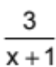 67. 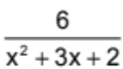 68. 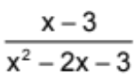
69. 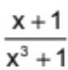 70. 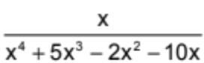 71. 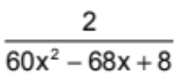
72. 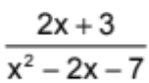

Combining rational expressions:

Sometimes rational expressions need to be combined. This can be done through multiplication, division, addition and subtraction. Remember all fractions work in the same manner.

To find the product or quotient of rational expressions, first factor each polynomial piece of the expression, then combine them by performing the indicated operation.

Simplify: 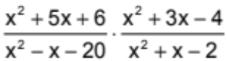

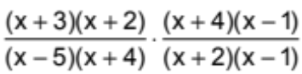

Note: A rational expression is simplified when its numerator and denominator have no common factors other than 1.

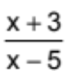

Divide: 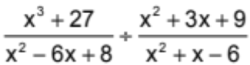
Note: When dividing fractions, multiply the first fraction by the reciprocal of the second fraction. This is sometimes known as keep, change flip. Keep the first fraction, change the sign, flip the second fraction.
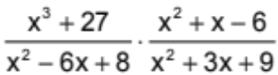

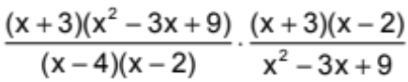
Note: You do not have to FOIL out the answer.

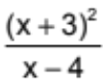

There are some special cases. These come from pairs of related binomials such as x + 2 and 2 + x or x – 2 and 2 – x. In the first case, 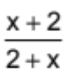, there is not issue to resolve. Using the Commutative Property of Addition you can transform the rational expression into 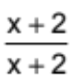 and therefore it will simplify into the number 1. The other pair of related binomials is a little different. In this case, 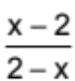, we cannot use Commutativity to transform the denominator. Even if you were to switch the terms (in an Algebraic Proof this would take 2 steps), you would end up with 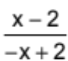. Since the numerator and denominators are not the same, canceling them does not work. In order to handle this problem, you need to factor out –1 from whichever binomial contains –x. In this case, now becomes 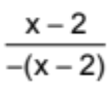. Now you can cancel out (x – 2). The answer is therefore –1.

If the numerator and the denominator contain conjugate binomials (x + 2 and x – 2) they cannot be modified to cancel.

Sometimes you will need to combine more than two polynomials. In this case remember your order of operations. If 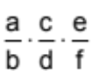, then the order does not matter. If 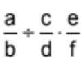 then 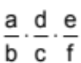. If 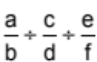 then 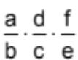.

Sometimes you may be asked to simplify rational expressions involving complex fractions (the numerator, the denominator or both contain a fraction). To complete the simplification you multiply by a rational expression equal to 1

Simplify: 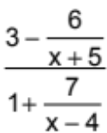
Note: This is called a complex rational expression since there is a fraction within a fraction.

To cancel out the (x + 5) in the numerator you would multiply the top by (x + 5). To cancel out the (x – 4) in the denominator you would multiply the bottom by (x – 4). However neither of these equals 1 and therefore performing the multiplication is not allowed unless it is done to both the numerator and denominator. Therefore we multiply by 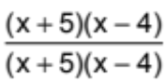.

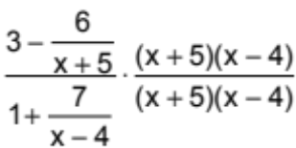

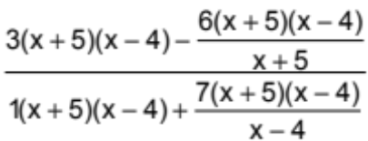

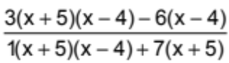
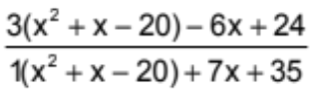
Note: It is always easier to multiply the binomials before distributing the constant.

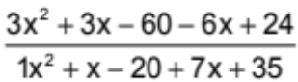

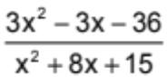

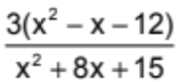

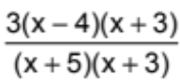

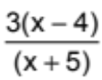

Simplify:

73. 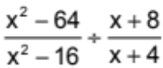 74. 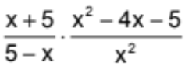 75. 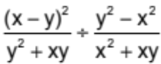
76. 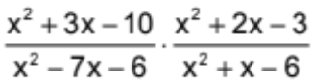 77. 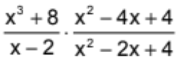 78. 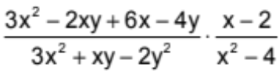
79. 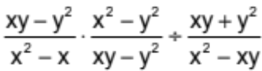 80. 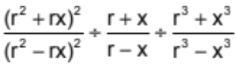 81. 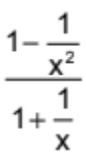
82. 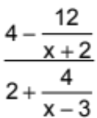 83. 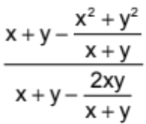 84. 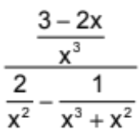
85. 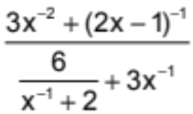

To find the sum or difference of rational expressions, first factor each polynomial piece in the denominator of the rational expression, then get common denominators for the rational expressions, next combine them by performing the indicated operation and finally factor the new polynomials in order to cancel out any common factors.

Simplify 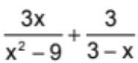:
Note: Remember that when you have x – 3 and 3 – x paired together, you factor –1 out of 3 – x to get –1(x – 3)
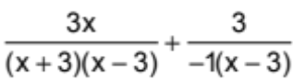
Note: If either the numerator or denominator is multiplied by –1, the entire fraction can be made negative. Thus you know are subtracting the rational expressions

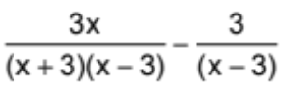
Note: Remember to distribute the negative (because of the subtraction of the rational expressions) to every term in the numerator of the second rational expression when combining them.

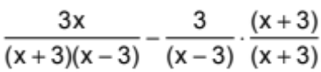

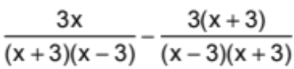

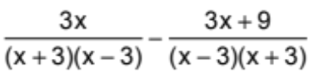

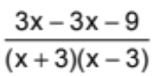
Note: This is a better form.

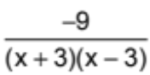

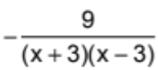

Simplify 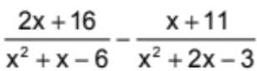:

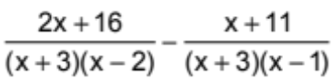

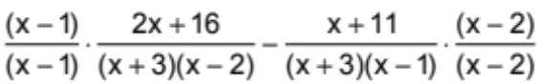
Note: When finding a common denominator, try to use the lowest common multiple (LCM). You will avoid extra work if you keep the denominator as small as possible.
Note: This step can be skipped, but it can help reduce careless error to write the numerator this way before distributing the negative sign.

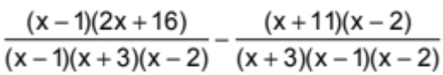

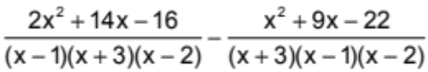

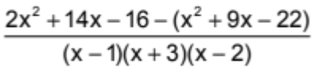
Note: Keep the denominator in factored form until the very end so that you will be able to cancel out common terms.

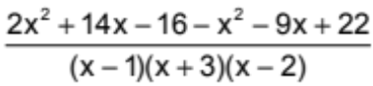

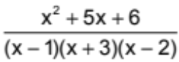

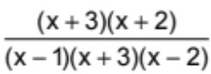

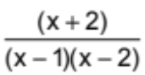

Note: Sometimes factoring the numerator will allow one or both of the rational expressions to be simplified before combining them. When possible, doing this first will make the problem easier.

Note: Some simple rational equations can be solved using the means-extremes products theorem.

Carry out the indicated addition and subtraction:

86. 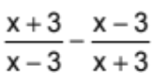 87. 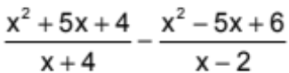 88. 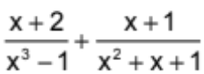
89. 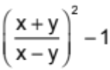 90. 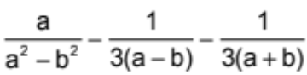 91. 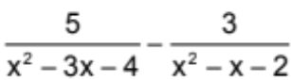
92. 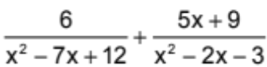

Simplify:

93. 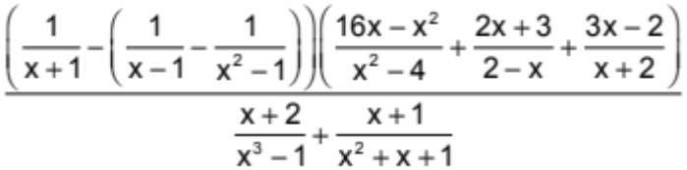

Next we will return to the reason we began to study factoring in the first place: it is a skill used in finding the domain of rational expressions. This concept is very important in finding the solutions of rational equations.

To solve rational equations first write the domain. Next multiply both members of the equation by the smallest expression needed to cancel out the denominators of the rational expressions (use the LCM). Then solve the resulting polynomial equation. Then discard any extraneous solutions. Finally write the solution set.

Note: To find the domain, make sure you factor each denominator.

Solve 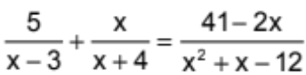:

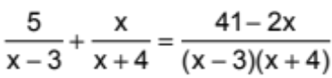

Domain = {x: x ≠ -4, 3}
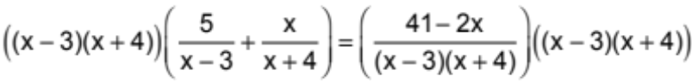

5x + 20 + x² – 3x = 41 – 2x
x² + 4x – 21 = 0
(x + 7)(x – 3) = 0
x = -7, x = 3
Since 3 is extraneous (it is not in the domain), S = {-7}. Note: You should check your answer to verify that computational mistakes were not made.

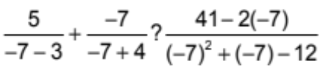

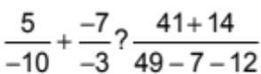

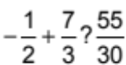

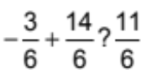

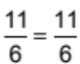 This checks.
Solve:
94. 3x² – 10x + 8 = 0 95. x³ – 5x² – 4x + 20 = 0 96. 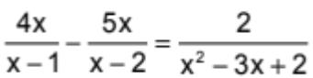
97. 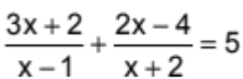 98. 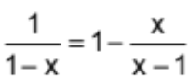 99. 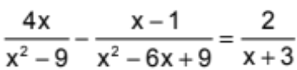
100. 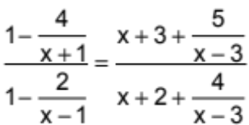
101. One positive number is five larger than another positive number. If the reciprocal of the smaller number is added to eight times the reciprocal of the larger number, the sum is equal to 1. Find the two numbers.
102. Working alone, Oren can paint a room in 5 hours. Liela can paint the same room in only 3 hours. How long would it take the two of them to paint the room if they work together?
103. Stephanie took her kayak to the Charles River, which flows downstream at a rate of 2 kilometers per hour. She paddled 15 km upstream, and then paddled downstream to her starting point. If this round-trip took a total of 4 hours, find the speed that Stephanie can paddle in still water.

You have now done enough work with rational expressions and equations to be introduced to rational functions.

A rational function has the form 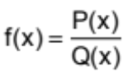, where P(x) and Q(x) are polynomial functions.

The parent graph of rational functions is the 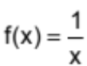, a special type of hyperbola. This is the most basic of the rational functions. Nothing is added to x or y to translate the graph. Nothing is multiplied to x or y to change its size. Neither x nor y are negative, therefore no reflections are occurring.

Domain = {x: x ≠ 0}, since it would not be allowed in the domain of the rational expression .

If you are to graph this rational functions you also need the range. A good way to discover this when unfamiliar with the function is to use a table of values and plot them on the graph.
Note: Since almost all of the y-values are non-integer rational numbers when the x values are rational, you might want to examine if the converse is also true.

xy-0.2-5-0.25-4-0.5-20.520.2540.25
-5
5
5
-5
x
y
Note: This parent graph is called an inverse variation function since every domain and range value can be switched within the function. It is symmetrical to itself about the line y = c.

Note:Range = {y: y ≠ 0}
x | y
-5 | 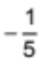 -0.2
-4 | 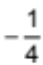= -0.25
-3 | 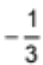≈ -0.33
-2 | 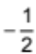= -0.5
-1 | 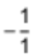= -1
0 | DNE (Does not exist)
1 | = 1
2 | = 0.5
3 | ≈ 0.33
4 | = 0.25
5 | = 0.2

Therefore the graph of f(x) = is:
x
5
5
-5
-5
y
Note: Since the Domain = {x: x ≠ 0}, you are approaching the y-axis but not crossing it. This means there is a vertical asymptote at x = 0. (Asymptotes are represented by dashed lines.)

Note: Since the Range = {y: y ≠ 0}, you are approaching the x-axis but not crossing it. This means there is a vertical asymptote at y = 0.

Therefore when graphing rational functions, the best way to start is to determine the domain and range of the function.

You will start by learning how the domain works. Later on in the packet you will discover how the range works.

Determine the Domain and Range of each rational function. Then sketch a graph.
104. f(x) = 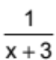 105. f(x) = 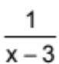 106. f(x) = 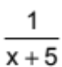

If you did these problems correctly, you should have discovered that what changed is the Domain. Therefore your vertical asymptote changed as the graph was shifted left or right.

Note: Since your range value did not change, this graph is no longer an inverse function as it no longer reflects over the line y = x.

Not all rational functions are this basic, as any polynomial is allowed to be in the numerator or in the denominator. Higher degree polynomials in the denominator change the domain of the function.

Find the domain and vertical asymptotes of f(x) = 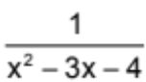:
First factor the numerator and denominator of the rational expression as needed. Then determine the domain.
f(x) = 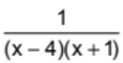
Domain = {x: x ≠-1, 4}
Vertical asymptote: x = -1, x = 4.

Both of these values are vertical asymptotes since they remain a problem no matter what. Therefore everywhere they occur they do not exist.

There are problem spots that are removable. These removable discontinuities become holes in the graph (represented by open circles).

To really understand the two types of problem spots, you must consider what is happening to f(x) when x approaches the value excluded from the domain. Using a numerical approach will help illustrate this concept.

Find the domain and vertical asymptotes of f(x) = 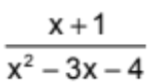:
f(x) = 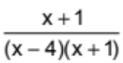
Domain = {x: x ≠-1, 4}
In this vase only x = 4 is a vertical asymptote. The other domain problem spot is removable when the rational function is simplified. Therefore it is only a problem in one spot and can be removed. This spot must be determined and becomes a hole in the graph.

To illustrate the difference between the two you should examine what is happening to f as x approaches the value that is to be excluded from the domain.

Vertical asymptote:
x approaches 4 from the right 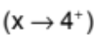

x | 4.1 | 4.01 | 4.001 | 4.0001 | 4.00001 | 4.000001 | 4.0000001
f(x) | 10 | 100 | 1000 | 10,000 | 100,000 | 1,000,000 | 10,000,000
f increases without bound. f approaches infinity 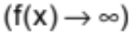

x approaches 4 from the left 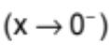

x | 3.9 | 3.99 | 3.999 | 3.9999 | 3.99999 | 3.999999 | 3.9999999
f(x) = | -10 | -100 | -1000 | -10,000 | -100,000 | -1,000,000 | -10,000,000
f decreases without bound. f approaches negative infinity 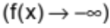

This illustrates asymptotic behavior; as you approach a value from two different sides, you increase or decrease without bound.

Note: Both sides can increase or decrease when finding an asymptote. An example of this will be shown later in the packet.

Removable discontinuity:
x approaches -1 from the right 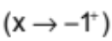

x | -0.9 | -0.99 | -0.999 | -0.9999 | -0.99999 | -0.999999 | -0.9999999
f(x) | -0.204 | -0.2004 | -0.20004 | -0.200004 | -0.2000004 | -0.20000004 | -0.200000004
f approaches –0.2 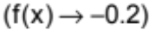

x | -1.1 | -1.01 | -1.001 | -1.0001 | -1.00001 | -1.000001 | -1.0000001
f(x) | -0.196 | -0.1996 | -0.19996 | -0.199996 | -0.1999996 | -0.19999996 | -0.199999996
x approaches -1 from the left
f approaches –0.2
This illustrates the removable discontinuity. You have one problem spot, a hole at (-1, -0.2). As you approach a value from two different sides, you approach the same numerical value.

This method of determining the problem spots is very time consuming. Therefore other approaches can be used. From an earlier discussion you know the vertical asymptote simplifies out and the removable discontinuity does not. Therefore it is easy to tell them apart. This simplification process will then help in determining the removable discontinuity.

To find the removable discontinuity, plug the removed problem spot into the simplified rational function.
f(x) =
= 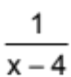
The Domain is still the Domain for the original rational function. The vertical asymptote is at x = 4, since this problem still exists in the simplified version. To find the removable discontinuity compute f(-1).
f(-1) = 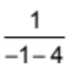
= 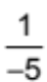
The removable discontinuity is therefore at 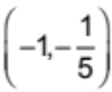 or (-1, -0.2).
Note: The removable discontinuity is a hole on the graph. It has a coordinate point value for the open circle that represents the hole.

Find any vertical asymptotes and removable discontinuities of the rational function. (Remember, if division by zero occurs in any equivalent form of the rational expression then it is either a vertical asymptote or a removable discontinuity.)
107. f(x) = 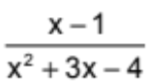 108. f(x) = 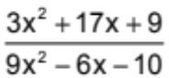 109. f(x) = 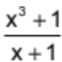
110. f(x) = 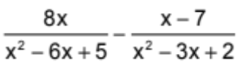 111. f(x) = 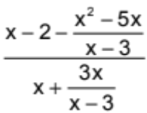

As discussed, the line x = a (sketched in as a dashed line) is a vertical asymptote for the graph f if f either increases or decreases without bound as x approaches a from the right of from the left.

The line y = b is a horizontal asymptote for the graph f if f approaches b as x increases without bound or as x decreases without bound.

To illustrate what is happening, you will examine the following 3 functions as x approaches infinity and as x approaches negative infinity:
a) 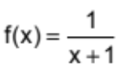 b) 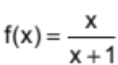 c) 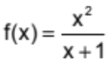

x | y |  | x | y |  | x | y
1 | 0.5 |  | 1 | 0.5 |  | 1 | .5
10 | 0.0909 |  | 10 | 0.909091 |  | 10 | 9.0909
100 | 0.0099 |  | 100 | 0.990990 |  | 100 | 99
1000 | 0.0009 |  | 1000 | 0.999000 |  | 1000 | 999
10,000 | 0.00009 |  | 10,000 | 0.999900 |  | 10,000 | 9,999
100,000 | 0.000009 |  | 100,000 | 0.999990 |  | 100,000 | 99,999
1,000,000 | 0.0000009 |  | 1,000,000 | 0.999999 |  | 1,000,000 | 999,999

x | y |  | x | y |  | x | y
-1 | error |  | -1 | error |  | -1 | error
-10 | -0.11111 |  | -10 | 1.111111 |  | -10 | -11.11111
-100 | -0.0101 |  | -100 | 1.0101 |  | -100 | -101
-1000 | -0.001 |  | -1000 | 1.001 |  | -1000 | -1,001
-10,000 | -0.0001 |  | -10,000 | 1.0001 |  | -10,000 | -10,001
-100,000 | -0.00001 |  | -100,000 | 1.00001 |  | -100,000 | -100,001
-1,000,000 | -0.000001 |  | -1,000,000 | 1.000001 |  | -1,000,000 | -1,000,001
x
y
5
-5
5
-5
x
y
5
-5
5
-5
x
5
-5
5
-5
y

y

As you can see, each case has the same vertical asymptote, as the domain = {x: x ≠ -1}, however they do not all have the same horizontal asymptote. In fact in part c, there is no horizontal asymptote. Examining the differences between the three cases will help you discover what is going on.

In case a, the degree of the numerator is less than the degree of the denominator. When this occurs, the horizontal asymptote is always the line y = 0 (the x-axis).

In case b, the degree of the numerator equals the degree of the denominator. When this occurs, you divide the leading coefficients to find the horizontal asymptote. In this case, both the numerator and denominator had leading coefficients of 1, therefore y = 1 is the horizontal asymptote.

In case c, the degree of the numerator is greater than the degree of the denominator. In this case there is no horizontal asymptote. The graph can reduce to another graph-able function that is known, or there may be
a slant asymptote. You will study slant asymptotes next year.

Find any horizontal asymptotes of the rational function. If no horizontal asymptotes occur state the name for the reduced function, or state that there is a slant asymptote.

112. f(x) = 113. f(x) = 114. f(x) =
115. f(x) = 116. f(x) =

Note: The graph of a function cannot cross vertical asymptotes. However, the same is not true for a horizontal asymptotes.

If you know the vertical asymptote(s) and removable discontinuity(s), horizontal asymptote(s) and a few other points the graph can be sketched without a table of values.

The critical values for sketching the graph of a rational function are the vertical asymptotes, the horizontal asymptotes, the removable discontinuities, the x-intercept(s), the y-intercept, and a few other points as needed.

Note: The x-intercept(s) and y-intercept only exist when the asymptotes are not the axes. Thus when they are the axis, you need a few other points for a good sketch.

From previous study you know that to find the y-intercepts, you set x = 0 and find y.

Find the y-intercept f(x) = 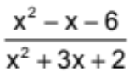:
f(0) = 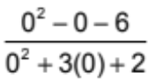
= 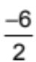
= -3
The y-intercept is at (0, -3).

Note: As these graphs are functions there will only at most one y-intercept.

From previous study you also know that to find the x-intercepts, you set y = 0 and find x.

Find the x-intercept f(x) = :
0 =
For a fraction to equal zero, the numerator must equal zero. The denominator is irrelevant as 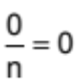, where n is any number. Therefore to find the x-intercept, you just need to make the numerator equal zero and find x.
0 = x² – x – 6
0 = (x – 3)(x + 2)
x = 3, x = -2
The x-intercepts are (3, 0) and (-2, 0).

Find any x-intercept(s) and y-intercept:
117. 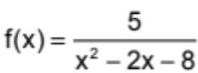 118. 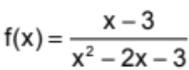 119. 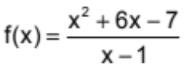
120. 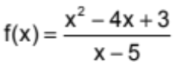

Sometimes you may need to find a few other points in order to get a good sketch.

Note: You should use your graphing calculator to check your sketch. You must do all of the work by hand, but it can help you with the overall shape.

Plot the graphs of the following functions. (You will encounter graphs we have not specifically discussed in this packet.)
121. 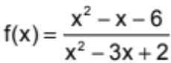 122. 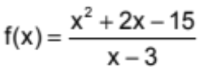 123. 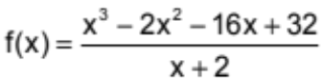
124. 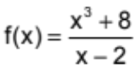 125. 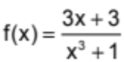 126. 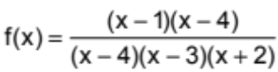
127. 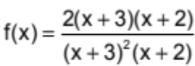 128. 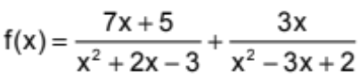

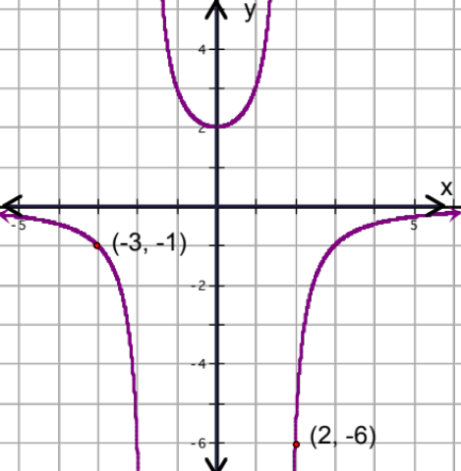
129. The graph of a function of the form f(x) = 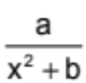 is shown. Find the values of a and b.
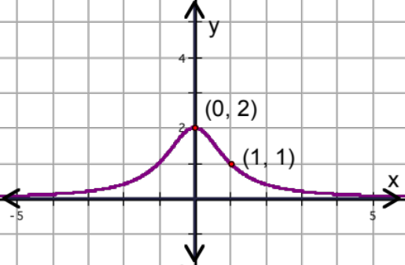
a. b.

Rational functions are frequently used as a mathematical model for a situation in which f(x) is equal to a constant multiplied or divided by a power of x. Theses rational functions are called variation functions.

Variation functions have the form:
y = kx^{n} or y = 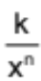
where k is a constant know as the constant of variation or proportionality constant, and n is the power.

When y = kx^{n}, y varies directly with the power of n. (y is directly proportional to the n^{th} power of x.) In this case, as x increases y increases. In this case the functions are monomial functions.

When y = , y varies inversely with the power of n. (y is inversely proportional to the n^{th} power of x.) In this case, as x increases, y decreases. In this case the functions are rational.

Note: y = kx^{n} can represent inverse variation if n is allowed to be negative.

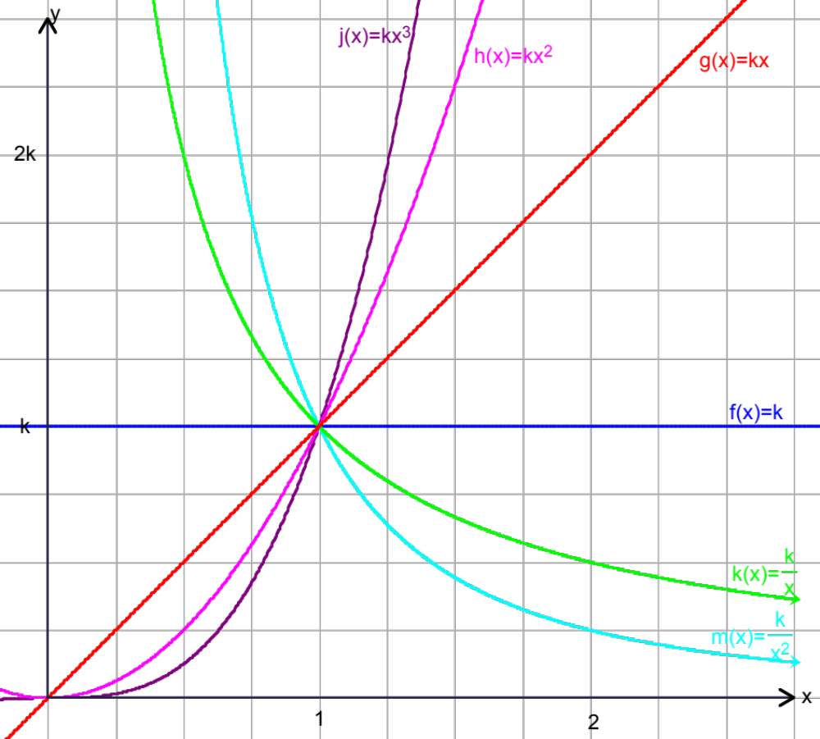

y is directly proportional to the cube of x
y varies directly with the square of x
y varies directly with x

y does not vary with x (k is a constant monomial)

y varies inversely with x

y is inversely proportional to the square of x

0

From previous study, you know that linear functions have an add-add property, exponential functions have an add-multiply property and polynomial functions have a property involving finite differences. Variation functions also have a property, it is the multiply-multiply property of variation functions. Some examples are below.
X | f(x) = 3x² |  | x | g(x) = 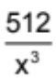
1 | 3 |  | 1 | 512
2 | 12 |  | 2 | 64
4 | 48 |  | 4 | 8
8 | 192 |  | 8 | 1
x 2
x 2
x 2
x 2²
x 2²
x 2²

x 1/2³
x 1/2³
x 1/2³

x 2
x 2
x 2

Example:
Tumors are sometimes treated by irradiating them with gamma rays from a radioactive source such as cobalt-60. The intensity of radiation you receive depends on how far you are from the source. Suppose that for a particular source, the intensity is 80 mr/hr (milliroentgens per hour) at 2 meters and 5 mr/hour at 8 meters.

a. How does the intensity vary with distance, directly or inversely?
It varies inversely since as one value increases, the other decreases.
b. Define your variables.
Let d = distance from source in meters (independent)
Let r = intensity of radiation in mr/hr. (dependent)
c. Write the general equation for any inverse variation function.
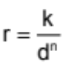
d. Find the value of the exponent, n.
d r .
2 80
x 4
x 1/16
8 5

Since 16 = 4², n = 2
e. Write the general equation for this situation.
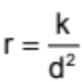
f. Write the particular equation.
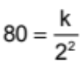

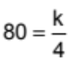

4(80) = k
k = 320
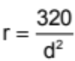
g. What would the intensity be if your distance was 16 meters?
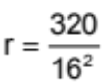
r = 1.25
The intensity would be 1.25 mr/hr
h. At what distance would the intensity be 0.5 mr/hr?
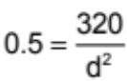

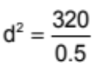

d² = 640
d ≈ 25.29822128
The distance would e about 25.3 meters.

130. When you swim underwater, the pressure in your ears varies directly with the depth at which you swim. At 10 feet, the pressure is about 4.3 pounds per square inch (psi).
a. Write the particular equation expressing pressure in terms of depth.
b. Predict the pressure at 50 feet.
c. It is unsafe for amateur divers to swim where the pressure is more than 65 psi. How deep can an amateur diver safely swim?
d. Plot the graph of pressure versus depth.
131. A cyclist travels 50 miles from her home to a state park at a speed of s miles per hour. N the return trip, she increases her speed by 5 miles per hour.
a. Write an equation in terms of s for the time the cyclist takes to travel from her home to the state park.
b. Write an equation in terms of s for the time the cyclist takes to return home from the state park.
c. Write an equation in simplified form for the total time of the cyclist’s trip.
132. A car travels 120 miles in the same amount of time that it takes a truck to travel 100 miles. The car travels 10 miles per hour faster than the truck.
a. Write an equation that relates the speeds to the two vehicles. (speed = distance/time)
b. How fast were the car and the truck traveling?
c. How much time t=did the vehicles spend traveling?
133. Sometimes a function is defined by different equations I different parts of its domain. For example, the weight of an object varied directly with its distance from the center of the Earth when the object is below the Earth’s surface, but is inversely proportional to the square of its distance from the center when it is above the surface. (Note: An object in orbit is considered “weightless” because its weight is exactly counterbalanced by the upward force due to its motion.)
a. Liela weighs 68 pounds at the Earth’s surface. Write the particular equation expressing her weight as a function of distance from the center (2 equations) assuming that the radius of the Earth is 4000 miles.
b. Predict Liela’s weight 3000, 8000, and 12,000 miles from the center.
c. Draw a graph f this function in the domain fro 0 though 12,000 miles.
134. The safe dosage of a new medicine is determined by testing it on animals. To predict the safe dosage for humans from the results of animal experiments, scientists assume that the safe dosage is directly proportional to the patient’s skin area. This area is then directly proportional to the square of the person’s height. (Assuming all patients have the same proportion.)
a. Write general equations for safe dosage in terms of skin area and for skin area I terms of height. (Use k₁ and k₂ to represent the different proportionality constants.)
b. Combine the two equations in order to get a general equation expressing safe dosage in terms of height. (You should make sure the proportionality constant is represented by only one variable, k₂.)
c. Tell in words how safe dosage depends on height.
135. A rectangular dog pen is to be made to enclose an area of 225 square feet.
a. If x represents the width of the pen, express the total length L(x) of the fencing material needed for the pen in terms of x.
b. Considering the physical limitations, what is the domain of the function L?
c. Find the dimensions of the pen that will require the least amount of fencing material.
d. Graph the function L, including any asymptotes.
e. Repeat parts a though d if the pen is to be divided into two congruent sections.
136. Suppose you are working at the Center for Disease Control. You get reports that a new disease has been detected. Three days after the first report, there are 100 cases of the disease. Six days after the first report, the number of cases has risen to 200. The table below shows the number of cases, C, and the number of days, D.
D | 3 | 6 | 9 | 12
C | 100 | 200 | 400 | 800

a. Based on this data, what is the most appropriate mathematical model, a linear function, an exponential function, or a variation function? Justify your answer.

b. Find the particular equation for this situation.
c. Show that your mathematical model is reasonable.
d. If nothing happens to stop it, when will 10,000 people have the disease?

